Blastp results 2.0 (Using ORF5 as query sequence to search for similarity inside the database)
Results (Top 5)
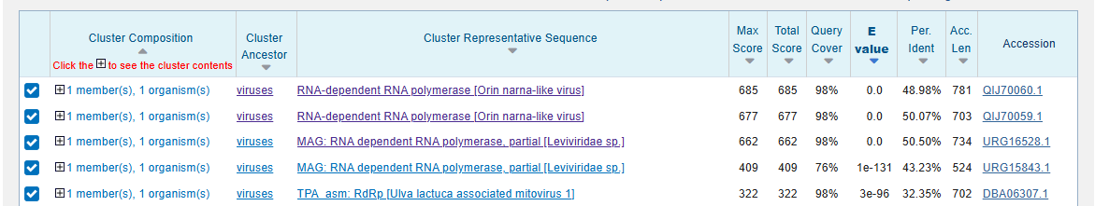
Per. Identity which is around 30%-50% with significant E-value
Among the top 5 list, 2 came from narnaviridae, another 2 came from leviviridae and 1 came from mitoviridae

Taxonomy Lineage Report
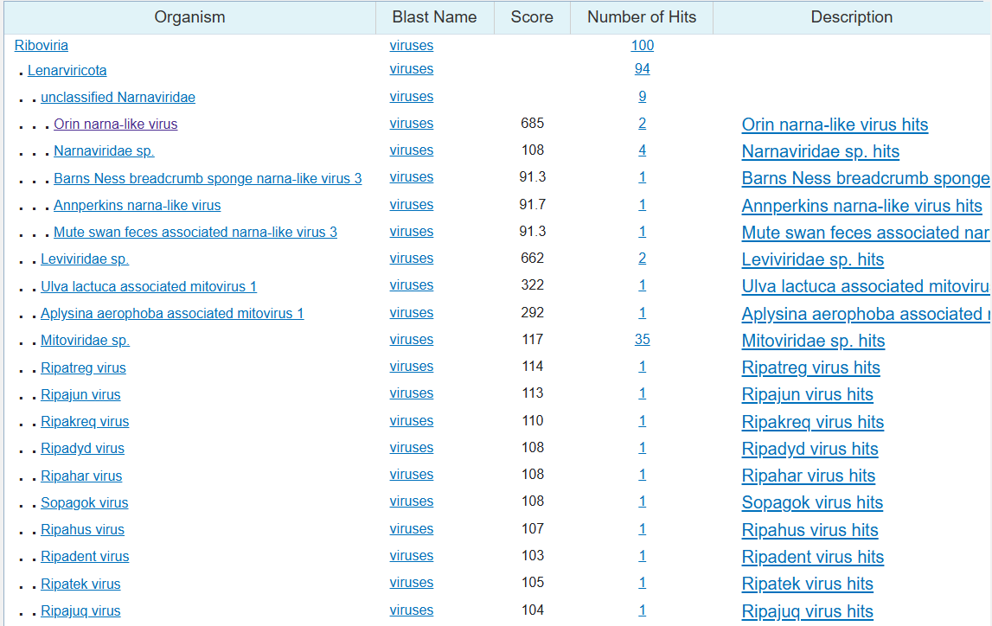
Showing high scores for the classification below:
Orin narna-like virus (685) which came from Leviviridae (622)

Using the predicted RdRp ORF (ORF5, 986 aa) as a query, I performed a BLASTp search against the protein database to assess its similarity to known viruses. The top five hits all showed moderate amino-acid identity (~30–50%) but strongly significant E-values, indicating clear homology while still reflecting substantial sequence divergence from any characterized virus . A taxonomy lineage report for these hits revealed that the best-scoring matches are annotated as Orin narna-like virus and related narnavirus-like RdRps , consistent with classification of the novel sequence within the Lenarviricota (narnavirus/mitovirus-like) RdRp clade. However, the relatively low full-length identity (only about one-third to one-half of residues conserved) shows that, although ORF5 is clearly an RdRp from the same lineage, it is sufficiently distant in sequence space to represent a distinct, previously undescribed viral species, rather than a re-discovery of an existing one. This conclusion is further supported by the higher conservation restricted to the 103-aa palmprint region (≈75–77% identity) compared with the rest of the polymerase, a pattern typical of novel species within established RNA-virus families.

